Project Information Report - Godrej Regal Pavilion

Project Summary
Sales Status: Sustenance
Construction Status: Excavation

Configurations (all of them) & Pricing (in Crs.)

Configuration | RERA/Saleable Area/SBU Size (sq. ft.) | Pricing Range (Agreement Value) In Cr. |  | Pricing Range (Agreement Value + GST) | Pricing Range (Agreement Value + GST + SDR)
2 BHK | 1307 - 1429 sq. ft. | 1.25 Cr. - 1.46 Cr. | 1.25 Cr + 5% |  | 1.25 Cr. + 5% + 8.15%
3 BHK Premium | 1642 - 1784 sq. ft. | 1.58 Cr. - 1.72 Cr. | 1.58 Cr + 5% |  | 1.58 Cr. + 5% + 8.15%
3 BHK Lux | 1872 - 2428 sq. ft. | 1.80 Cr. - 2.41 Cr. | 1.80 Cr + 5% |  | 1.80 Cr. + 5% + 8.15%
3.5 BHK | 2673 sq. ft. | 2.49 Cr. - 2.73 Cr. | 2.49 Cr. + 5% |  | 2.49 Cr. + 5% + 8.15%
4 BHK Premium | 2883 - 2904 sq. ft. | 2.59 Cr. - 2.92 Cr. | 2.59 Cr. + 5% |  | 2.59 Cr. + 5% + 8.15%
4 BHK Lux | 3444 - 3571 sq. ft. | 3.18 Cr. - 2.52 Cr. | 3.18 Cr. + 5% |  | 3.18 Cr. + 5% + 8.15%

RERA: Possession & OC Timelines
  - RERA Number: P02400009910
  - RERA Certificate Link: https://rera.telangana.gov.in/
  - Possession Timeline As Per RERA (Month and Year): August 2030
  - Possession Timeline Target As Per GPL (Month and Year): August 2029

Payment Plan
Payment Plan - Construction Linked Plan
How it will work for this project (with demo illustration of the calculation):

3 BHK P Cost Sheet
Total Cost For Customer |  | 1,79,81,030.17
Total Agreement Value |  | 1,68,58,298
Milestone | % | 3 BHK - 1782 sq. ft. | Logic
Advance towards Booking Amount | 5% | 8,85,060.64 | 5% of Agreement Value + 5% GST Value
Balance booking amount payable within 15 days of booking | 5% | 8,85,060.64 | 5% of Agreement Value + 5% GST Value
Within 60 days from the date of booking | 10% | 17,70,121.29 | 10% of Agreement Value + 5% GST Value
Commencement of Excavation or 1st Feb 2026, whichever is later | 5% | 8,85,060.64 | 5% of Agreement Value + 5% GST Value
Completion of Excavation for respective tower | 10% | 17,70,121.29 | 10% of Agreement Value + 5% GST Value
Completion of 4th floor slab for respective tower | 5% | 8,85,060.64 | 5% of Agreement Value + 5% GST Value
Completion of 9th floor slab for respective tower | 5% | 8,85,060.64 | 5% of Agreement Value + 5% GST Value
Completion of 14th floor slab for respective tower | 10% | 17,70,121.29 | 10% of Agreement Value + 5% GST Value
Completion of 19th floor slab for respective tower | 5% | 8,85,060.64 | 5% of Agreement Value + 5% GST Value
Completion of 24th floor slab for respective tower | 10% | 17,70,121.29 | 10% of Agreement Value + 5% GST Value
Completion of Terrace floor slab for respective tower | 10% | 17,70,121.29 | 10% of Agreement Value + 5% GST Value
Completion of flooring of the respective unit | 10% | 17,70,121.29 | 10% of Agreement Value + 5% GST Value
On Notice of Possession | 10% | 17,70,121.29 | 10% of Agreement Value + 5% GST Value
On Notice of Possession: Advance Maintenance & Sinking Fund Charges | 0% | 2,79,817.30 | Advanced Maintenance & Sinking Fund Charges + 18% GST of Advanced Maintenance Value
Total |  | 1,79,81,030.17

Additional 0.5% (Agreement of Sale) after initial 10% payment and additional 7.65% SDR later at the time of possession

* This illustration is for representation purposes only. The actual calculation and monthly payout may vary depending on the (i) unit selected in which tower (ii) associated charges for that unit and (iii) the offers available at project marketing office.

Floor Plans

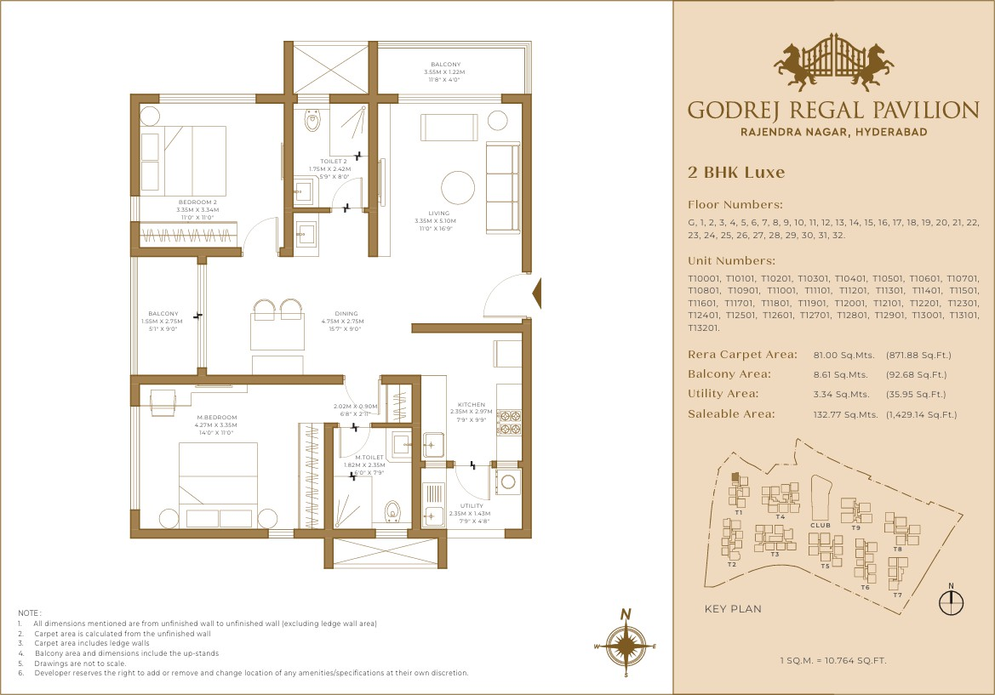

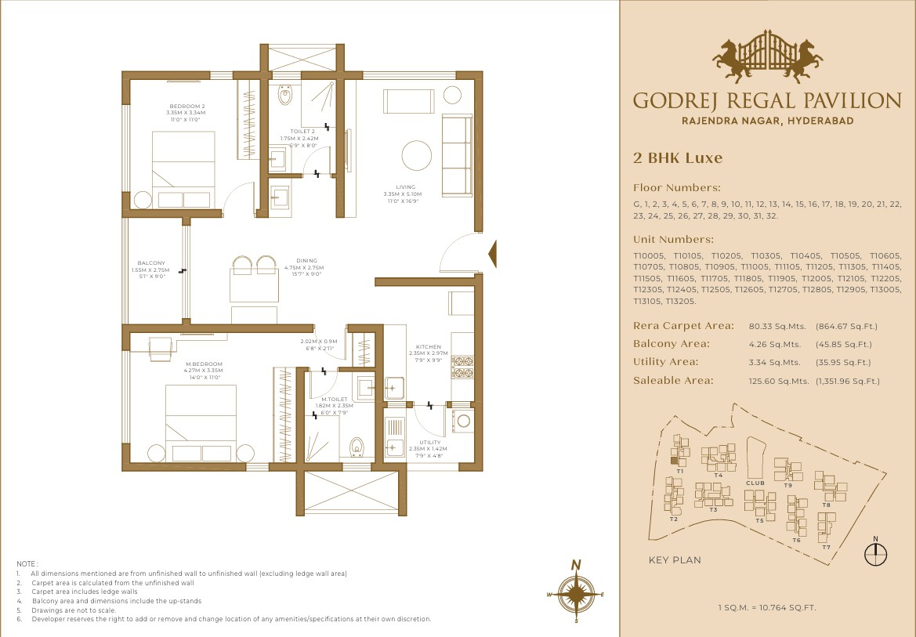
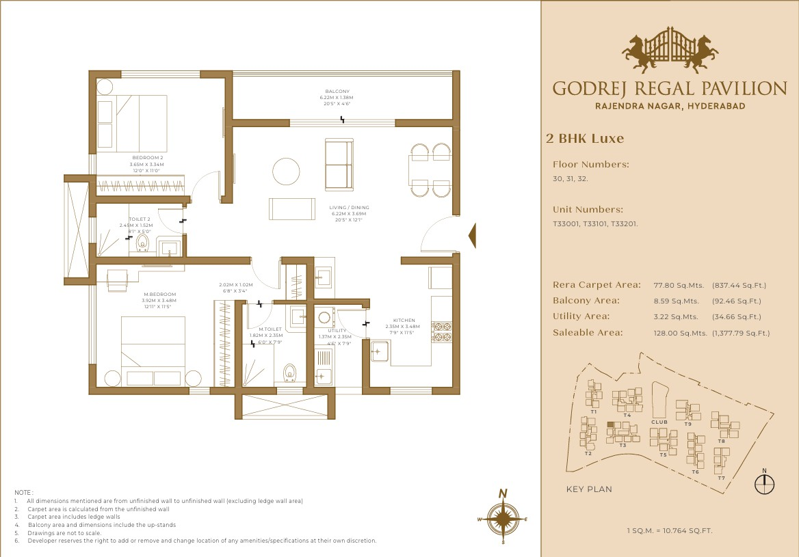

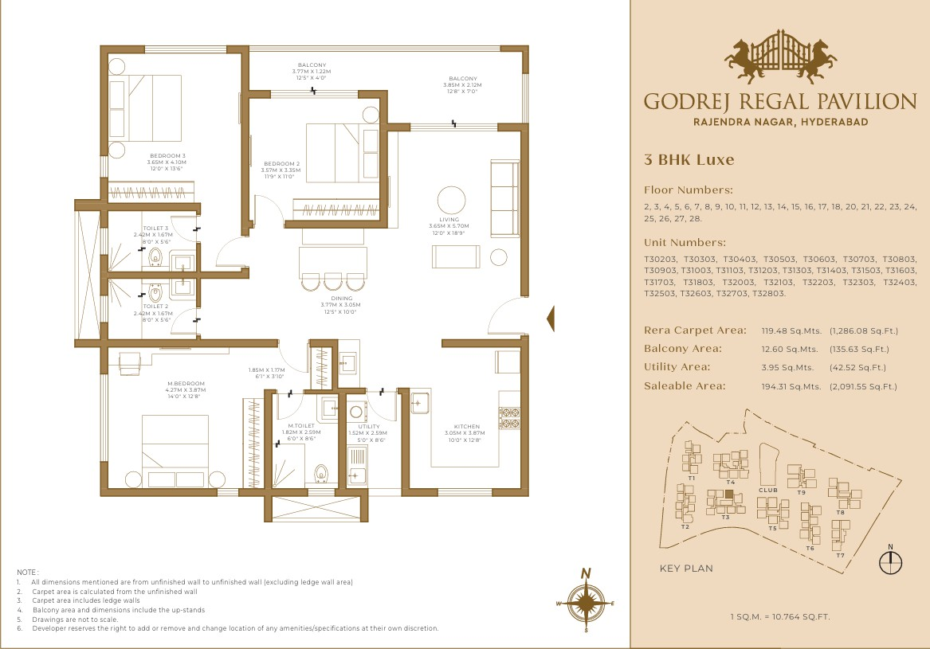
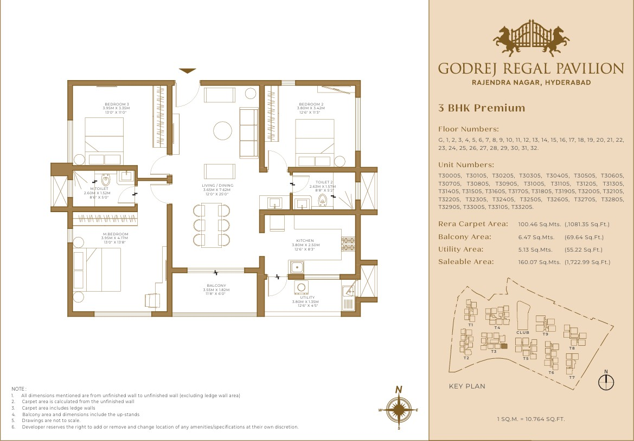

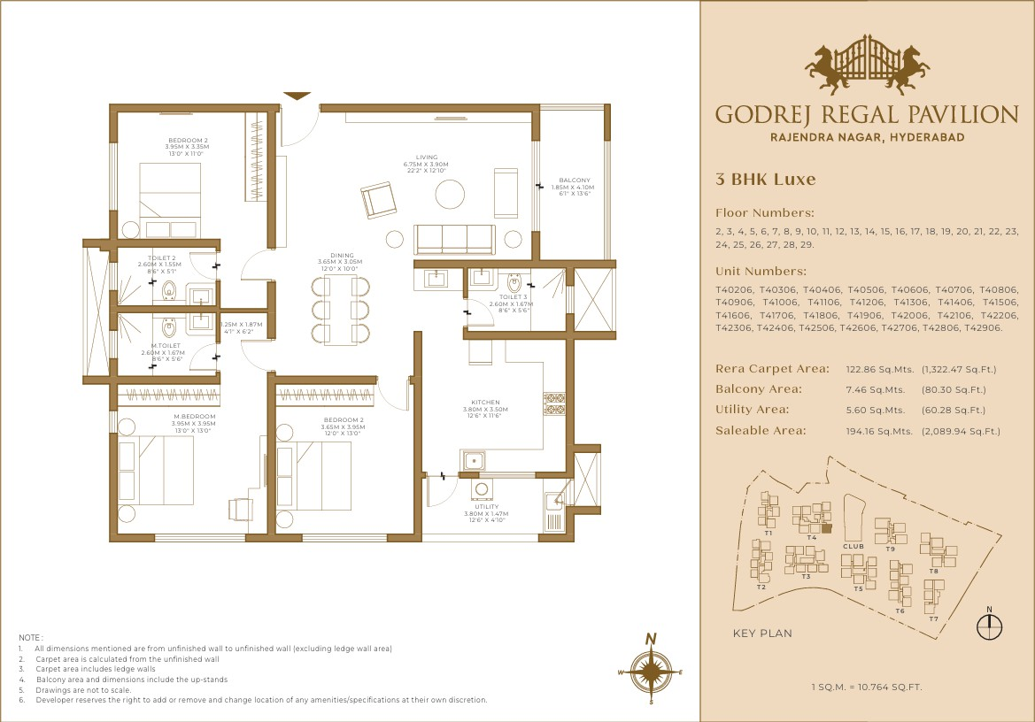

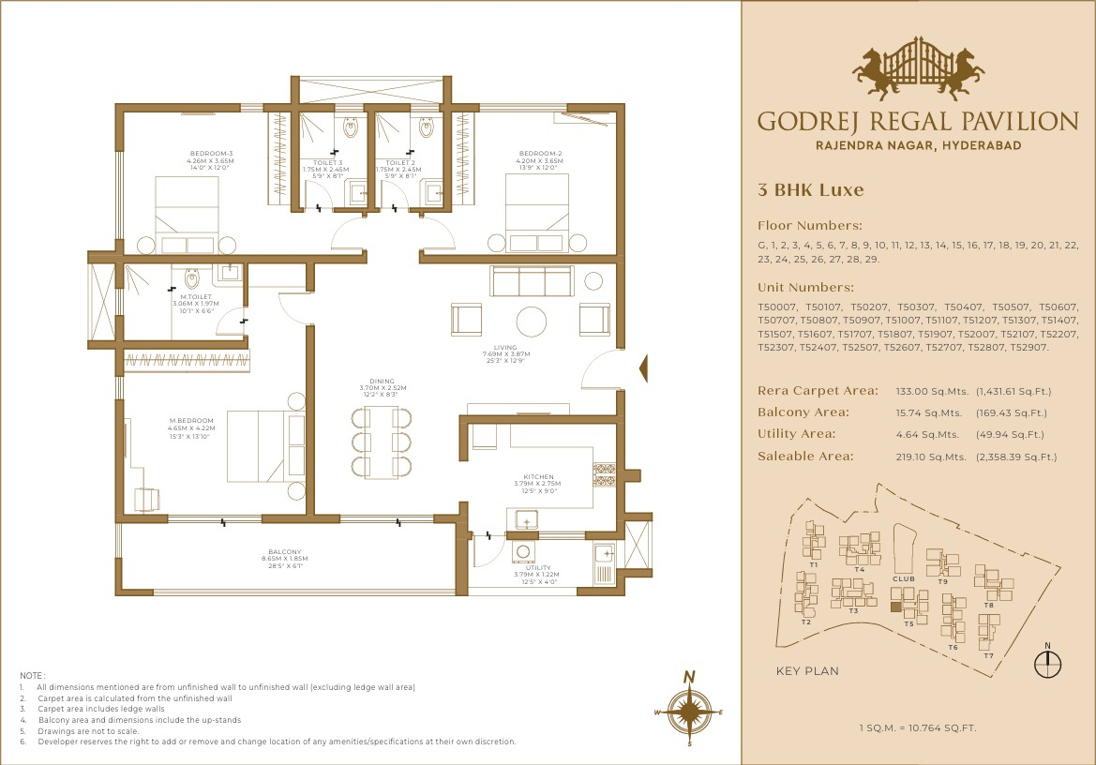

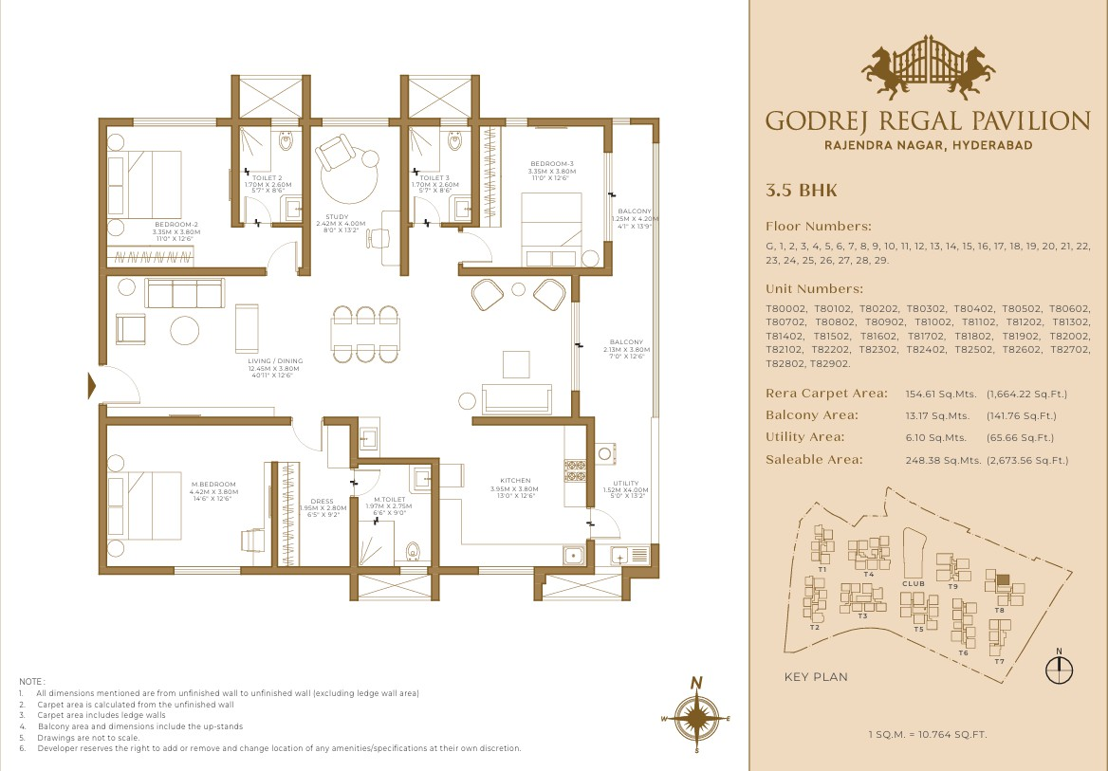

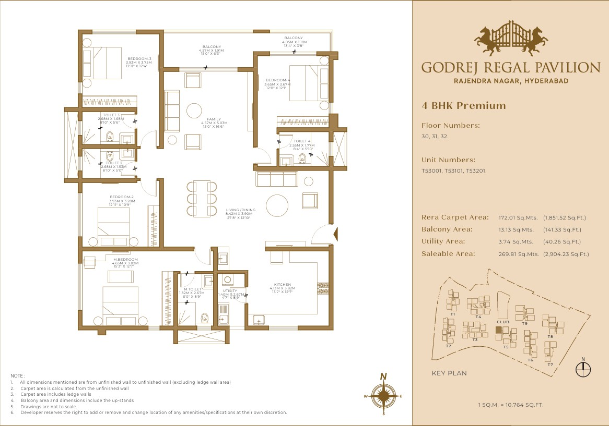

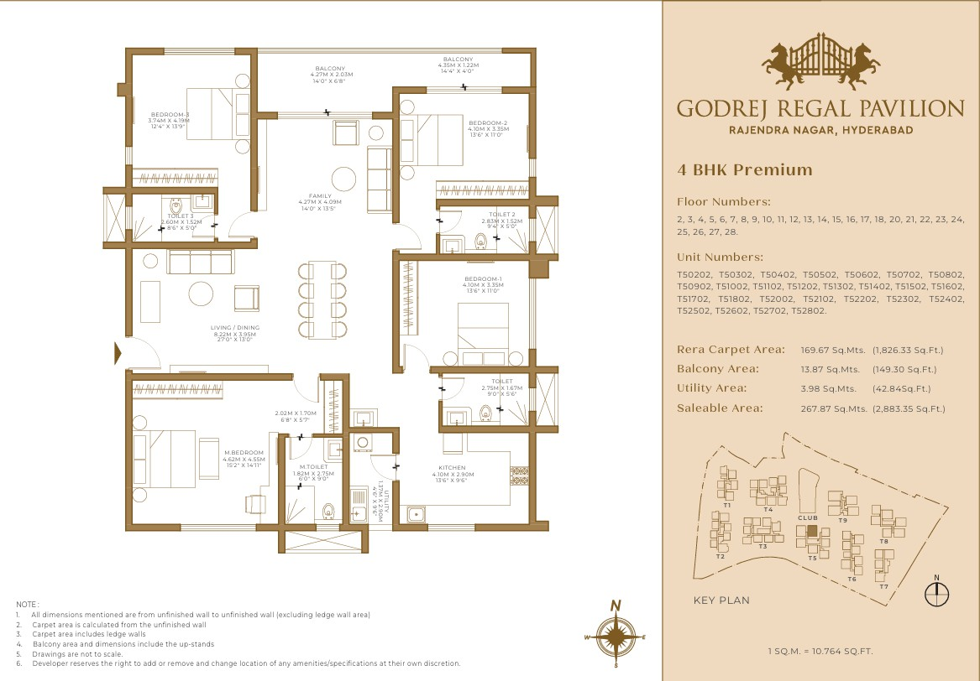

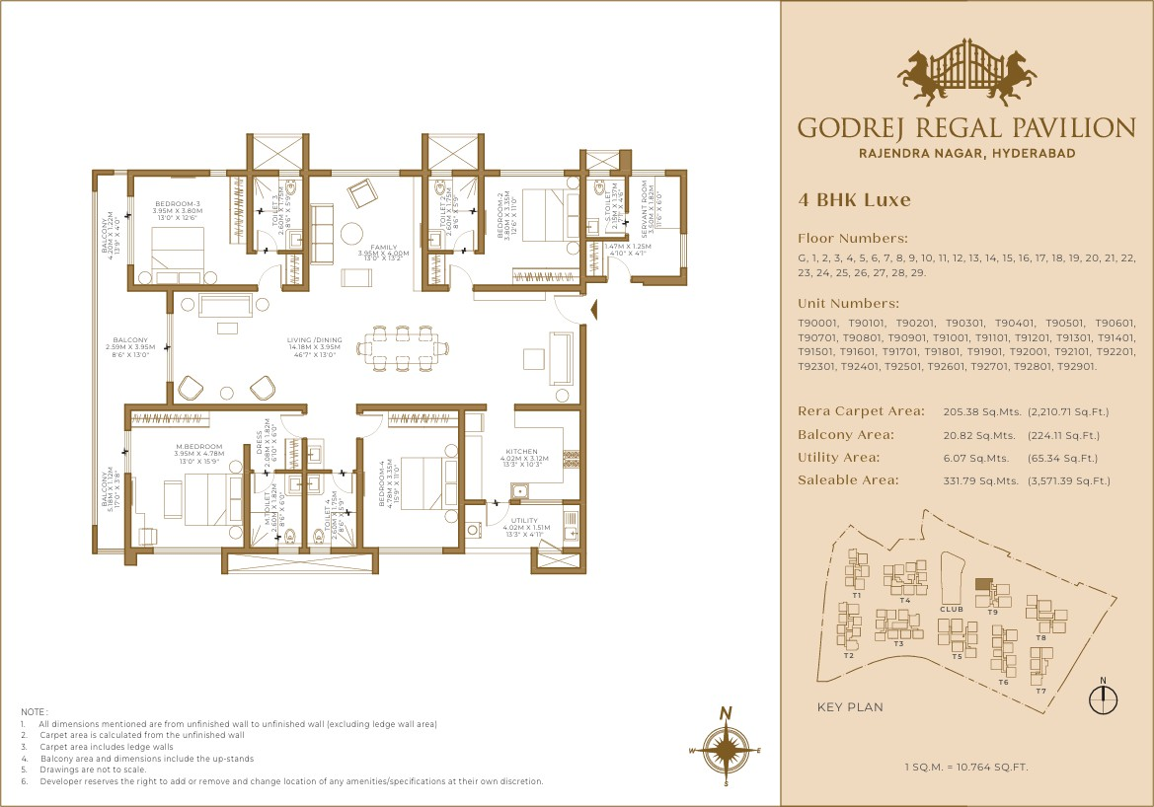

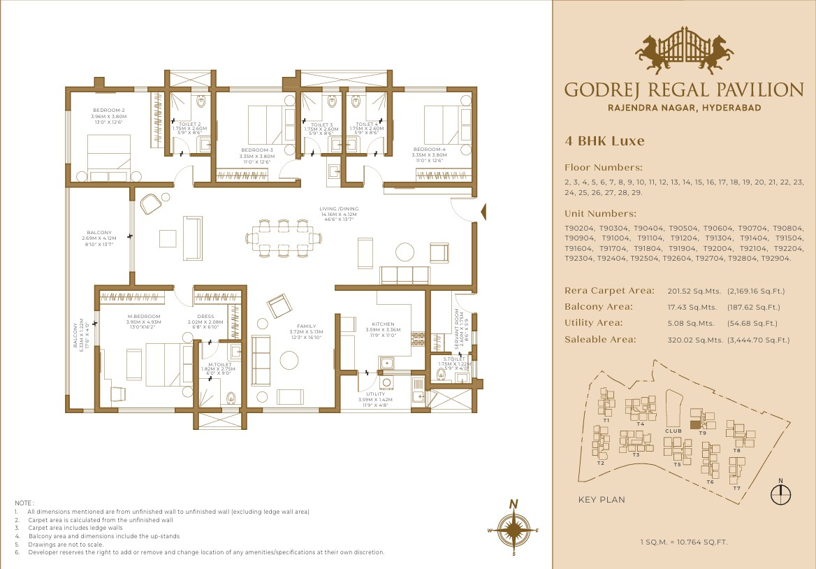

Location Advantages

Schools & Colleges
  - Rockwell School – 10 min*
  - Basil Wood School – 15 min*
  - Edify World School – 15 in*
  - Delhi Public School – 25 min*
  - Glendale Academy – 25 min*

Entertainment
  - Forum Mall (Upcoming) – 5 min*
  - Neo Mall (Upcoming) – 5 min*
  - Mantra Mall – 15 min*
  - Asian Mall – 15 min*
  - GMR Aero Plaza – 15 min*
  - GVK One Mall – 30 min*

Healthcare Facilties
  - Trident Hospital – 10 min*
  - Sunrise Hospital – 10 min*
  - Olive Hospital – 25 min*
  - Premier Hospital – 25 min*
  - Kims Hospital – 25 min*
  - Care Hospital – 30 min*

Social Infrastructure
  - Rajiv Gandhi International Airport –15 min*
  - Proposed Metro – 5 min*

Micro Marketing Understanding

Rajendranagar has transformed from a predominantly institutional and residential suburb into one of Hyderabad's fastest-growing real estate corridors. Its strategic location between the Financial District and Rajiv Gandhi International Airport positions it as the natural growth extension of West Hyderabad.
Rajendranagar is transitioning from an emerging suburb into Hyderabad's next major premium residential micro-market. Its combination of strategic location, infrastructure investment, employment connectivity, branded developer activity, and relatively attractive pricing creates a compelling proposition for both end-users and longterm investors. Recent market estimates place average residential pricing around ₹7,000–
₹9,500 per sq. ft., with 30–45% appreciation over the past five highlighting its growth trajectory.

Key Facts
  - Located approximately 12–15 km from Gachibowli & Financial District.
  - 15–20 km from Rajiv Gandhi International Airport via the Outer Ring Road (ORR).
  - Residential property prices have appreciated by approximately 30–45% over the last five years, depending on the micro-location and project.
  - The locality is evolving from an affordable market into a mid-premium residential destination due to branded developer participation.

Growth Drivers
  - Expansion of Hyderabad's western IT corridor.

  - Excellent ORR connectivity.
  - Availability of large land parcels.
  - Planned commercial and institutional developments.

Major Employment Hubs
  - Financial District
  - Gachibowli IT Corridor
  - HITEC City
  - Shamshabad Airport Ecosystem
  - Budwel IT & Commercial Corridor (proposed)
  - Logistics & Warehousing along NH-44

Major Institutions
  - Professor Jayashankar Telangana State Agricultural University (PJTSAU)
  - National Institute of Rural Development and Panchayati Raj (NIRDPR)
  - University of Hyderabad (nearby)
  - National Academy of Agricultural Research Management (NAARM)

Existing Infrastructure
  - Outer Ring Road (ORR)
  - PV Narasimha Rao Expressway
  - NH-44 Connectivity
  - Airport connectivity within 20–25 minutes

Upcoming Growth Catalysts
  - Proposed 350-acre IT Cluster between Budwel and Kismatpur.
  - Budwel Growth Corridor.
  - Expansion of commercial developments around Rajendranagar.
  - Continued infrastructure investments along the ORR growth corridor.

Buyer Profile

End Users (≈60–70%)
  - IT professionals
  - Government employees
  - Airport professionals
  - Families upgrading to gated communities
Investors (≈30–40%)
  - NRIs
  - High-income salaried professionals
  - Long-term capital appreciation investors
  - Buyers priced out of Kokapet and Financial District

Typical Budget
₹1.10 Crores - ₹2.5 Crores
The demand is shifting from first-time buyers to aspirational premium homebuyers seeking branded developments.

Developer Activity & Market Maturity
Rajendranagar has entered the Branded Developer Phase, which is typically a sign of market maturity and confidence.

Leading Developers Active in the Corridor other than GPL
  - Prestige Group
  - Ramky Estates
  - Provident Housing
  - Aparna Constructions

FAQs Used By Sales & Pre-Sales Teams

  - Where exactly is the project located? –
Godrej Regal Pavilion is located in Rajendranagar, adjacent to NH 44.

  - What is the possession timeline? August 2029

  - What is the starting price?
1.34 Cr onwards.

  - How far is the airport? 16 mins from airport

  - Is this a good investment? Yes, due to:
    - Airport Expansion
    - Proximity to India’s biggest high court
    - 1500 Acres of GMR Aerocity

Legal Disclaimers

RERA Registered. RERA No: P02400009910; Project: Godrej Regal Pavilion, Survey No: 253/P, 254, 255, 256/P, 259/P, at Gagan pahad , Rajendranagar, Ranga Reddy, 500052; Website: https://rera.telangana.gov.in/

Stock images for representation purpose only. The images contain artist’s impressions. No warranty is expressly or impliedly given that the completed development will comply in any degree with such artist’s impression as depicted. The furniture, accessories, paintings, plantations, landscaping, items, electronic goods, additional fittings / fixtures, decorative items, false ceiling including finishing materials, specifications, shades, sizes and colour of the tiles, etc. shown in the image are only indicative in nature and are only for the purpose of illustrating / indicating a conceived layout and do not form part of the standard specifications / amenities / services to be provided in the unit and / or the Project. The Sale is subject to terms of Application Form and Agreement for Sale. All specifications of the unit shall be as per the final agreement between the Parties. Recipients are advised to apprise themselves of the necessary and relevant information of the project prior to making any purchase decisions. The official website of Godrej Properties Ltd. Is www.godrejproperties.com. Please do not rely on the information provided on any other website. *T&C Apply.

